Assign the roles to users in Jenkins:

Step 1: we need to install the Role-based-strategy plugin from manage plugins 🡪 available plugin

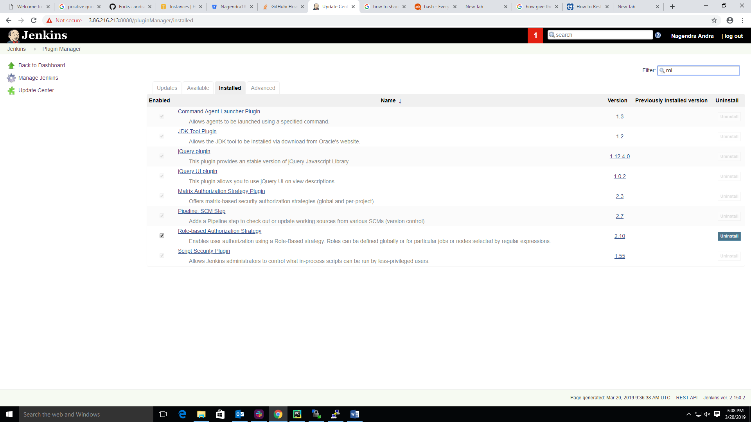

Step 2: Now, we need to move the Configure Global security and double click on this button.

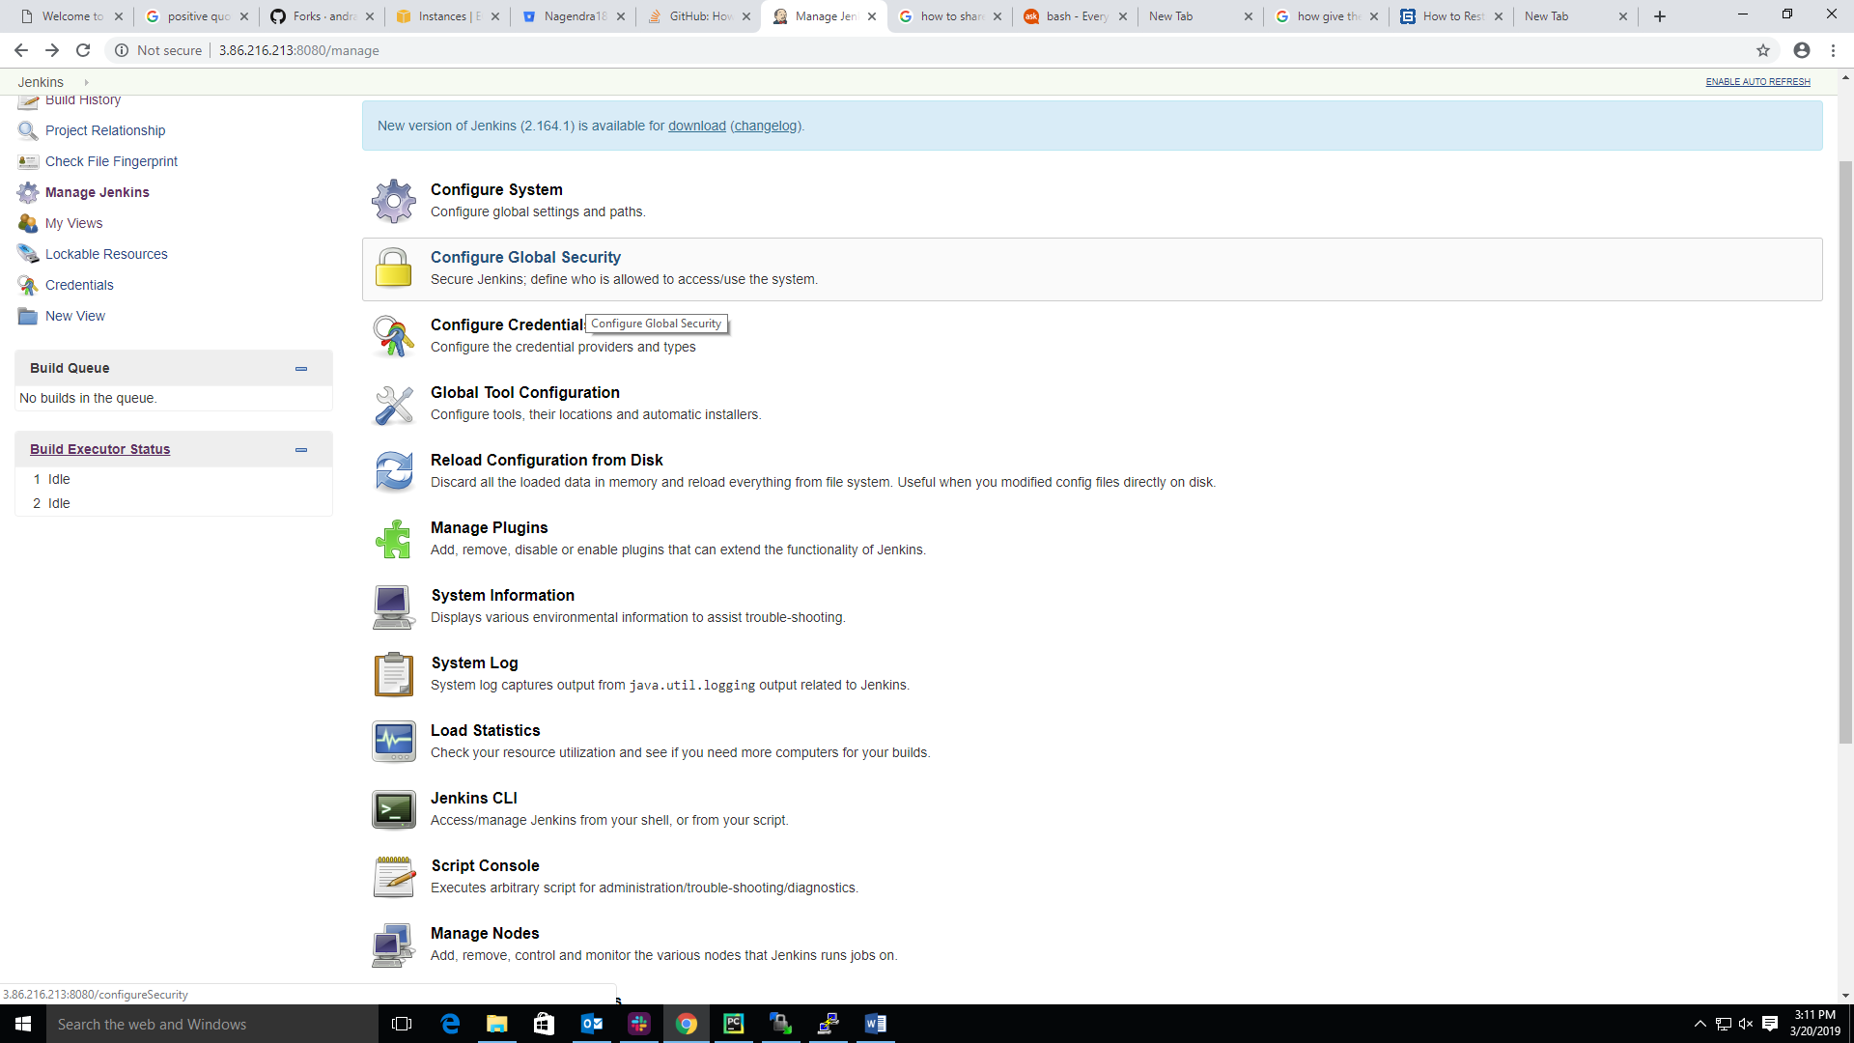

Step 3: we need to go enable security then go to the authorization section select the Role based strategy

Click on apply and save as shown in below screen shot.

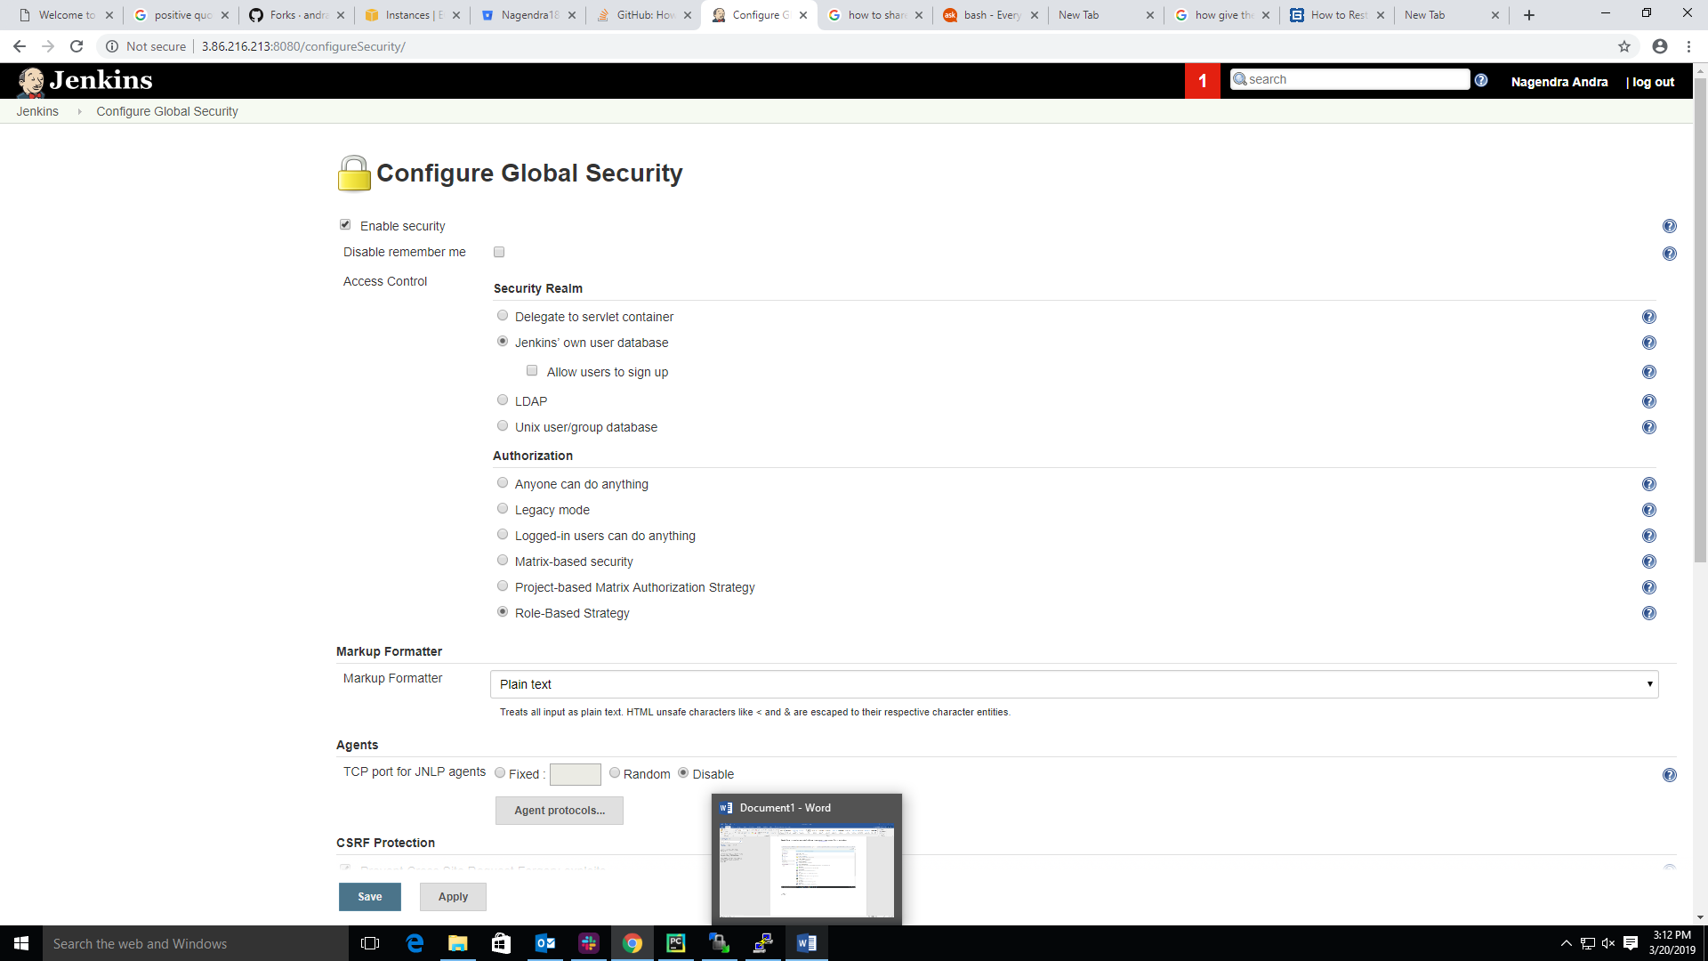

Step 4: we need to manage Jenkins here once we will see the manage and assign roles option as shown in below screen shot after completion of above step 3.

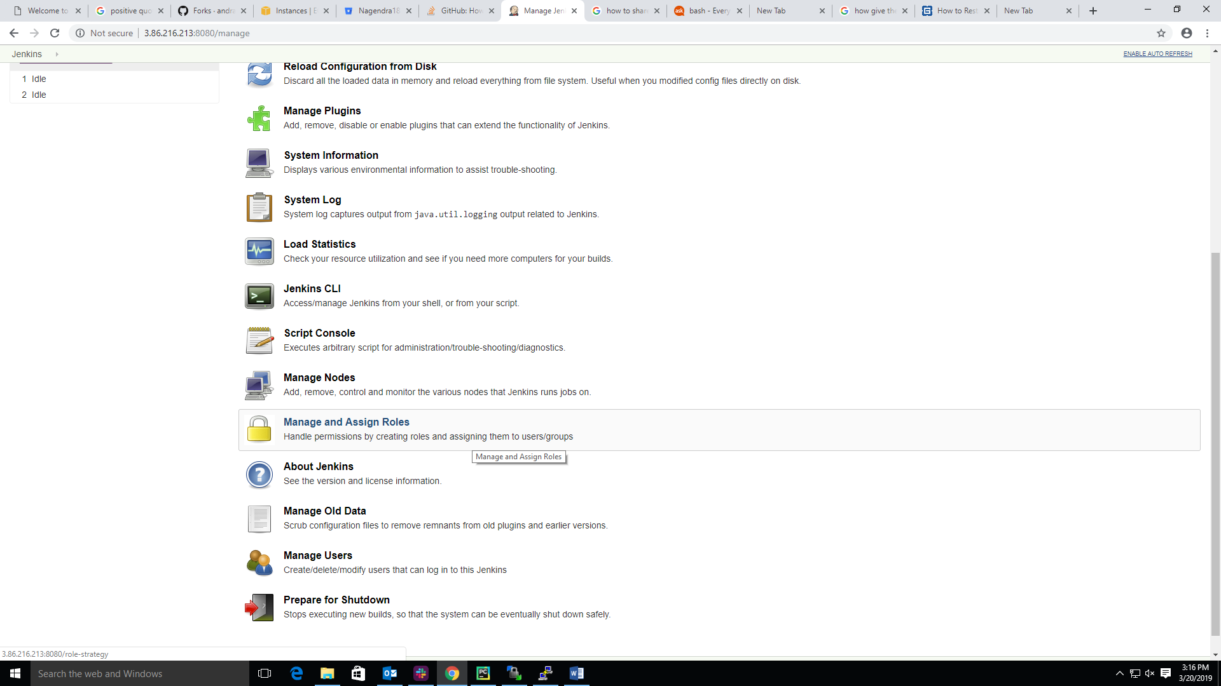

Step 5: After double click on manage and assign role we can see the below screen as shown in below screen shot.

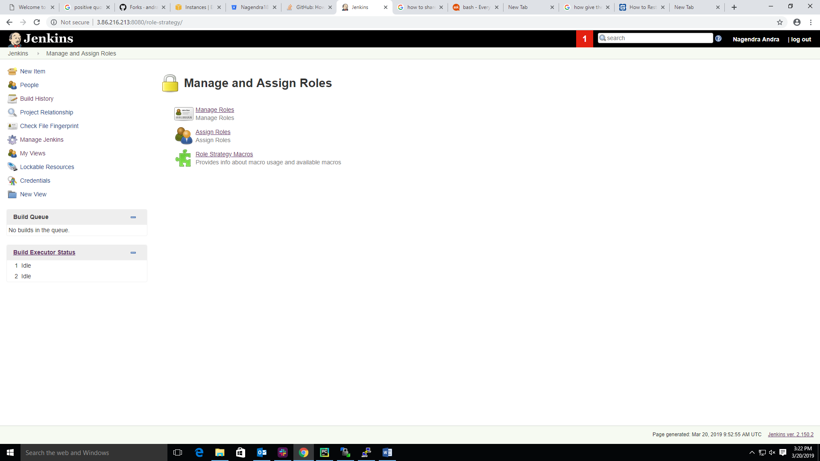

Step 6: first, we need to create the manage roles then assign roles. If we need to create roles go to the manage role section.

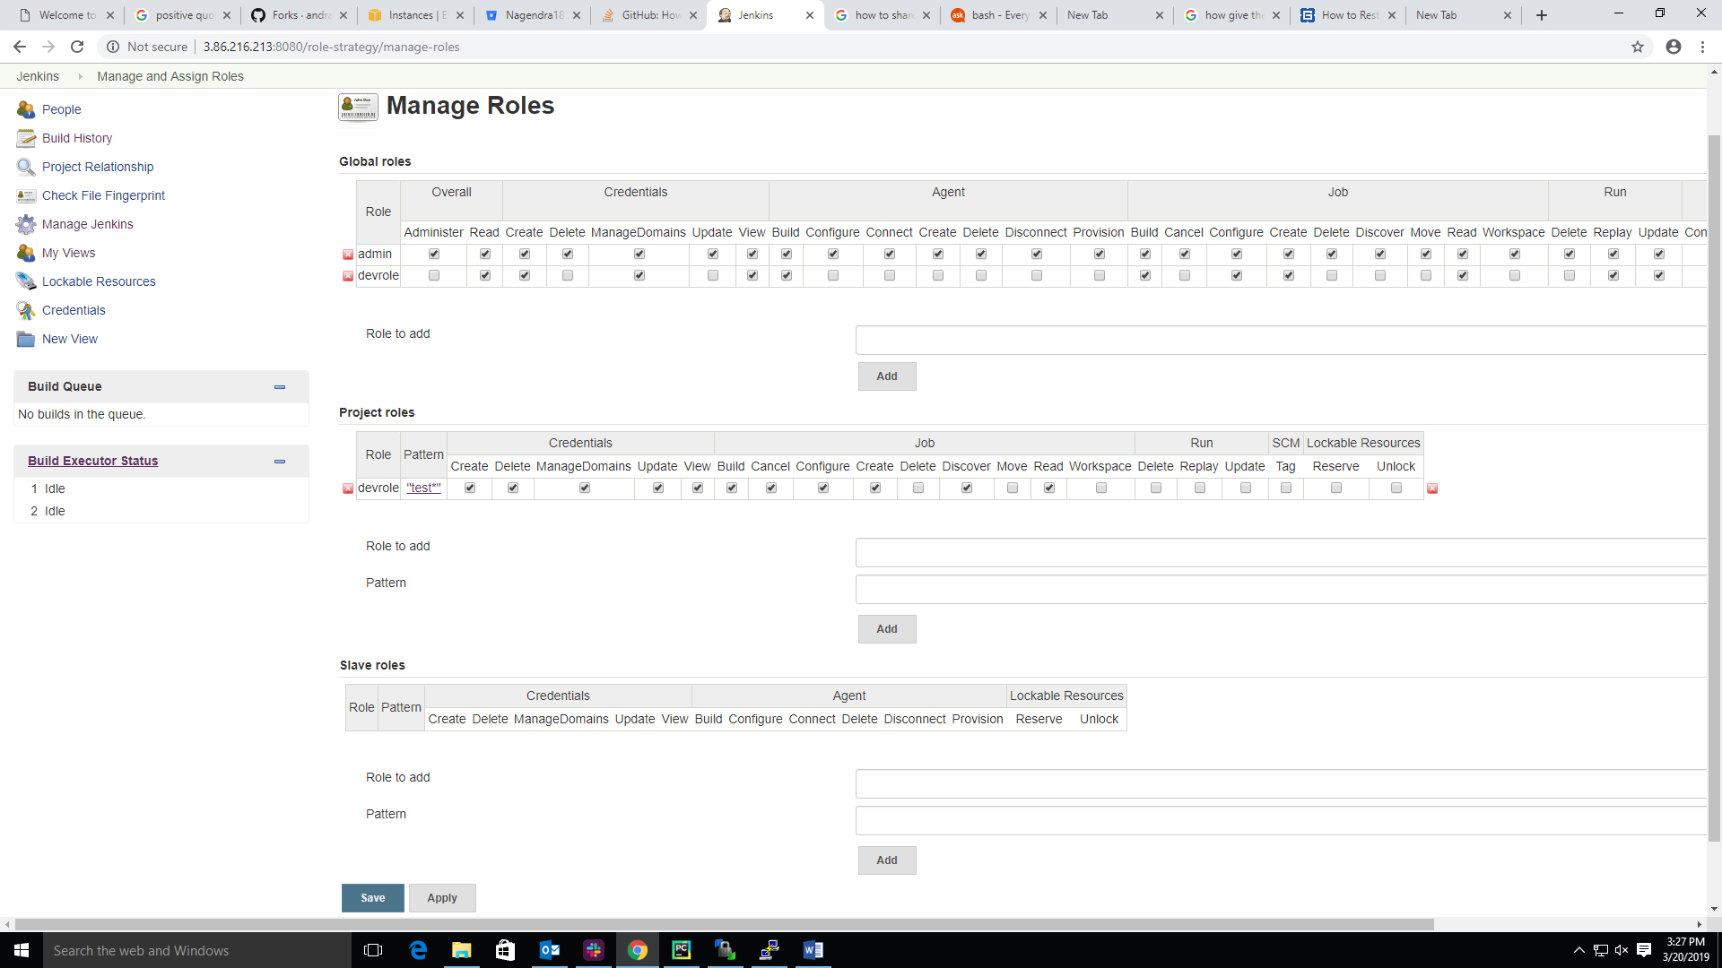

Step 6.1: first we create the Global role as shown in below screen shot.

In this section role/group: enter the role name unique assign permissions



Step 6.2: Now, we need to create the project level role permission once complete then click apply and save.

Role add: role-name

Pattern: jobs pattern, click on Add then give the permissions

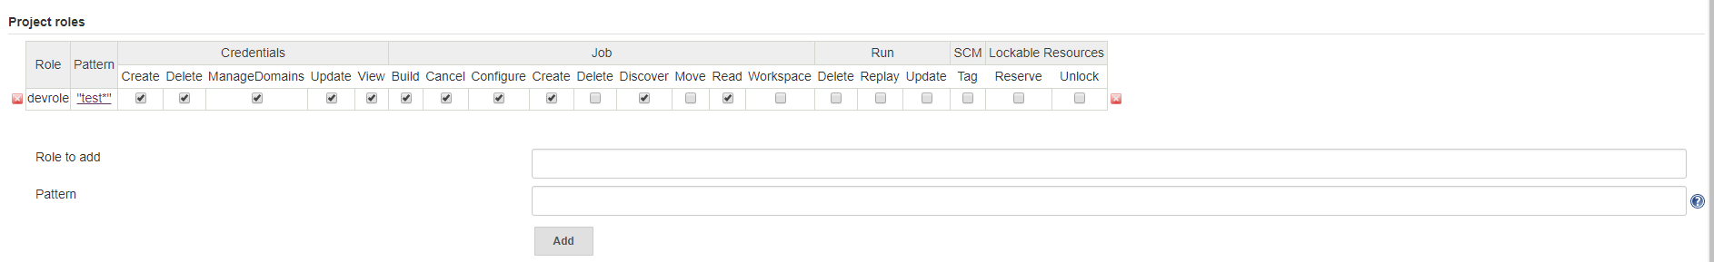

Step 7: Now, we assign the roles to users click on assign roles below screen shot displays assign roles dashboard.

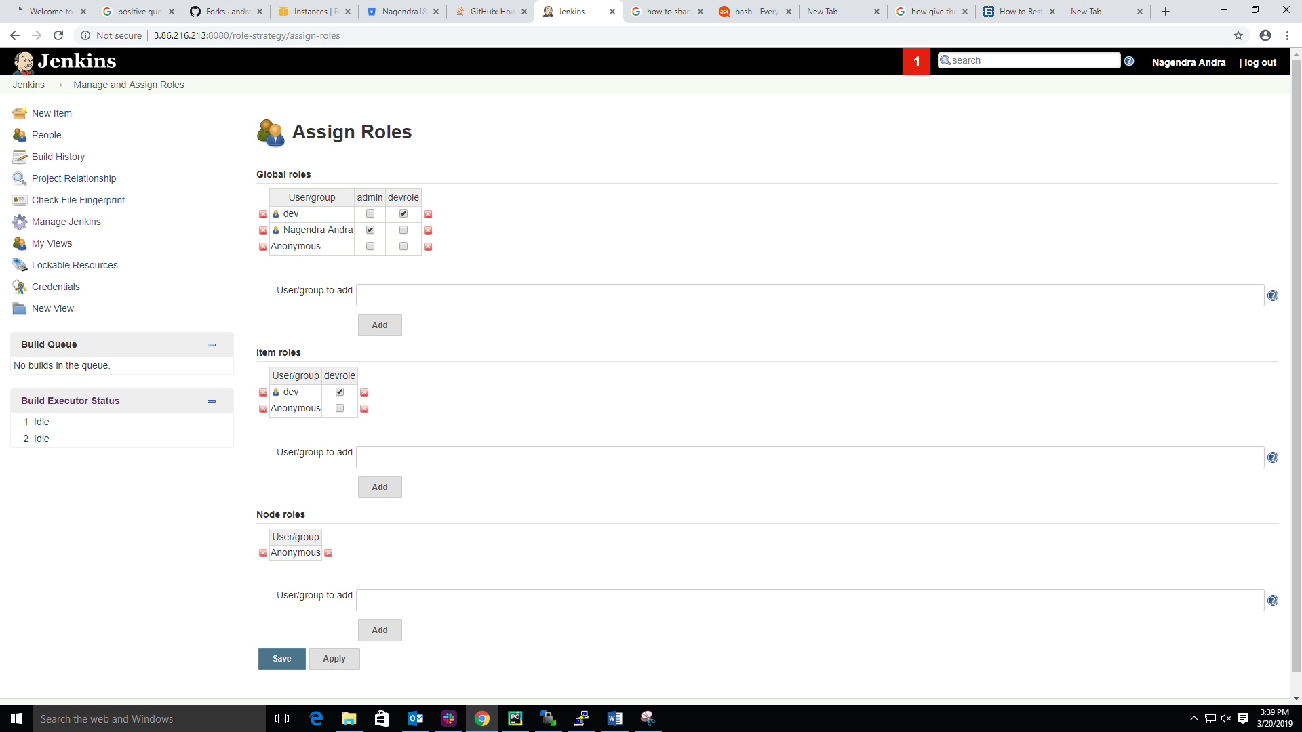

Step 8: Now, we add the user on global roles then select role to assign to particular user.

User/group: add the user name

